**Lab 4 – B00058026**

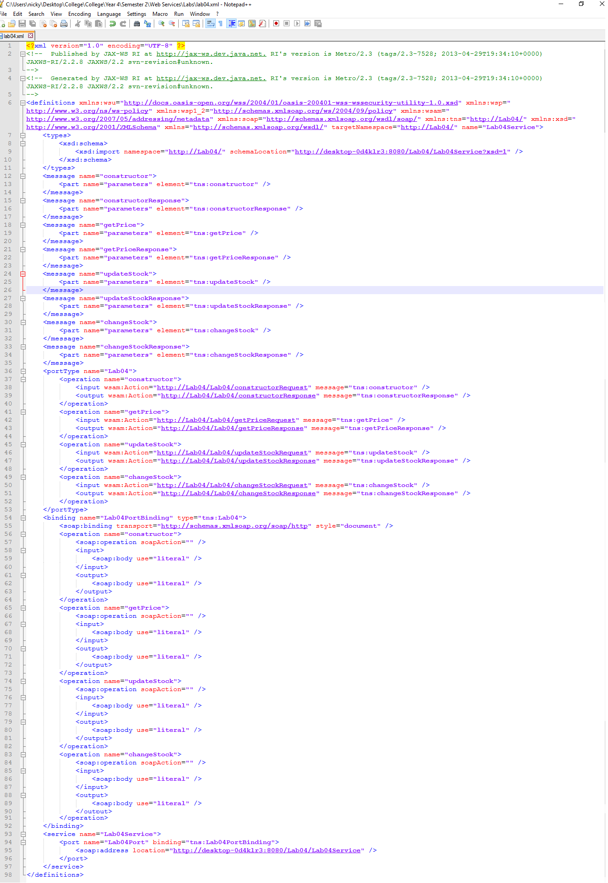

**Types**

The types element contains the user defined data types.

**Interface and Operations**

The interface is an abstract definition of the web service which does not have an information about where and how the service is provided.

An operation describes the input and output data structures.

**Input and Output**

Input and output refers to the input and output messages.

**Binding types**

Binding defines the protocol and data format for each port type.